Instruction

This document describes the workflow of how to get the high-resolution structural network.

Ref. Taylor P.N., Wang Y., Kaiser M. (2017). Within brain area tractography suggests local modularity using high resolution connectomics. *Scientific reports*, 7, 39859. doi: 10.1038/srep39859

***Step 1:***

Download data from the Human Connectome Project (HCP) website: <https://db.humanconnectome.org/>

We here download the preprocessed data, take subject (ID: 100307) for example, data is shown in file folders: 100307_3T_Diffusion_preproc; 100307_3T_Structural_preproc_extended.

***Step 2:***

Fiber tracking using ‘DSI studio’ software (Fig.1). The detailed manual about DSI studio is shared online: <http://dsi-studio.labsolver.org/>

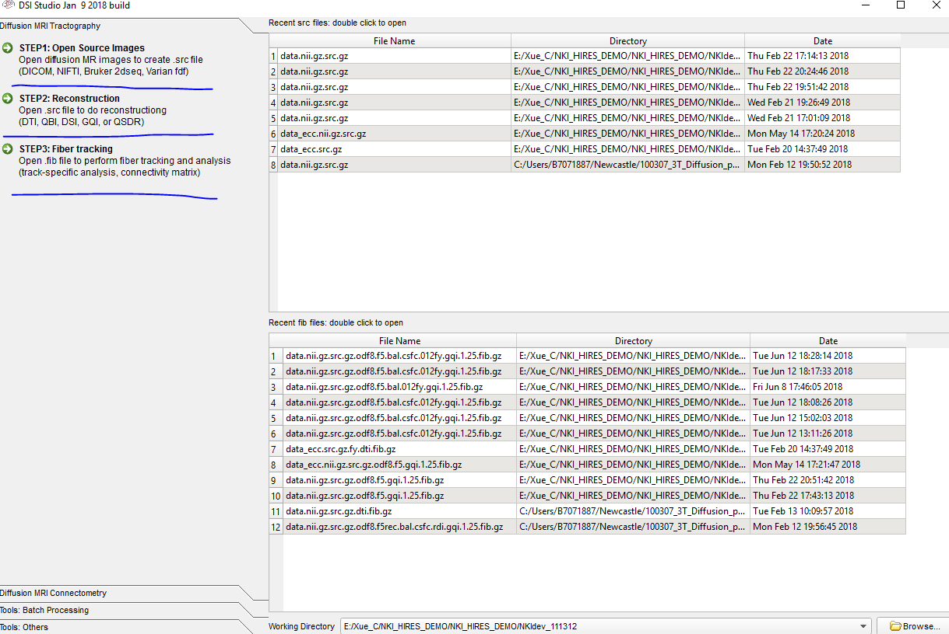

Fig.1 DSI studio

1. **Open Source Images:**

Following the path: 100307_3T_Diffusion_preproc/100307/T1w/Diffusion, choose the diffusion data: ‘data.nii’; and open ‘bvals’, ‘bvecs’ files under the same path (Fig.2). Then we will get the ‘data.nii.gz.src’ file.

1. **Reconstruction:**

Following above path, open ‘.src’ file and select reconstruction method, set other options (Fig.3) which are consistent with the settings shown in reference (Taylor et al., 2017).

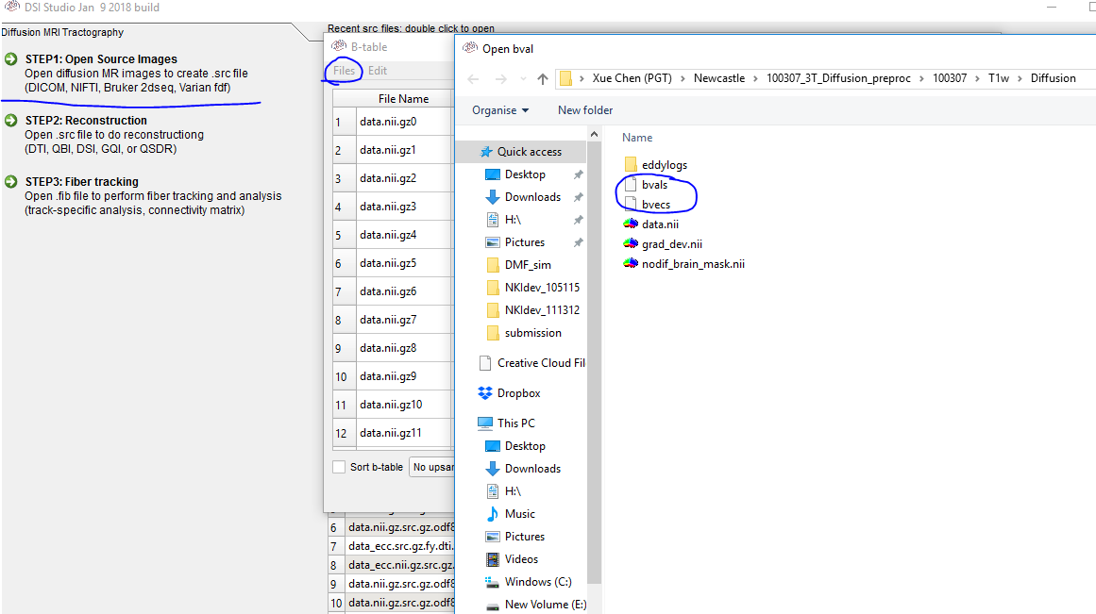

Fig.2 Open Source Images

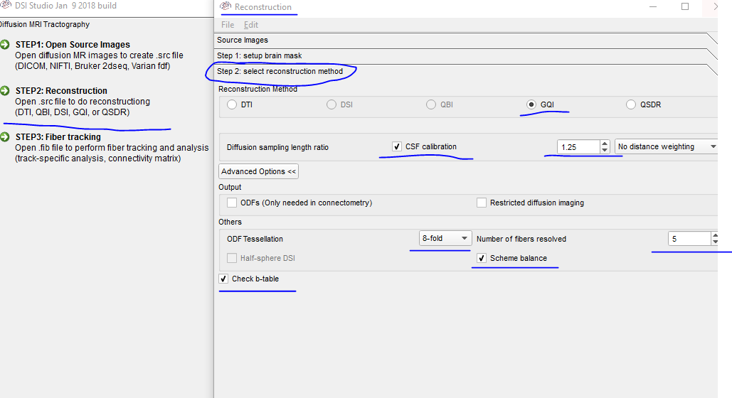

Fig.3 Reconstruction

1. **Fiber Tracking:**

Following above path, open ‘.fib’ file and insert ‘aseg+aparc.nii’ as T1w/T2w slice, so that the final tracking files can be mapped into the same space of ‘aseg+aparc.nii’ file (Fig.4).

Note: The ‘aseg+aparc.nii’ file is obtained using the following command in **Freesurfer software**:

**mri_convert aparc+aseg.mgz aparc+aseg.nii**

This command converts ‘aparc+aseg.mgz’ file into ‘aparc+aseg.nii’ file. And ‘aparc+aseg.mgz’ file is stored in /100307_3T_Structural_preproc_extended/100307/T1w/100307/mri/aparc+aseg.mgz.

Then set all tracking parameters according to the reference (Taylor et al., 2017). Note that the default value of qa threshold is 0.6*(Otsu’s threshold). Then, click ‘Fiber Tracking’ and finally **save tracks in T1w/T2w space, that is aparc+aseg.nii space (‘Tracks->Save Tracks->Save Tracks in T1/T2 space’)** (Fig.5).

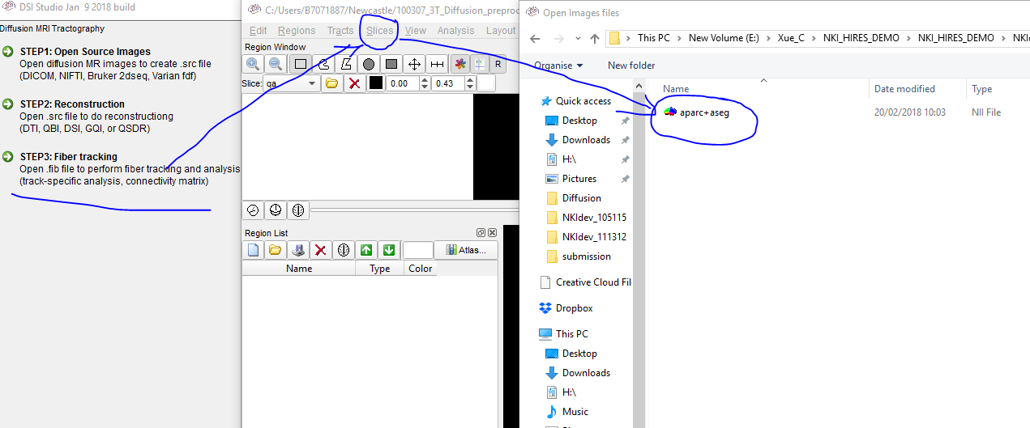

Fig.4 Fiber Tracking (insert atlas file as T1w/T2w slice)

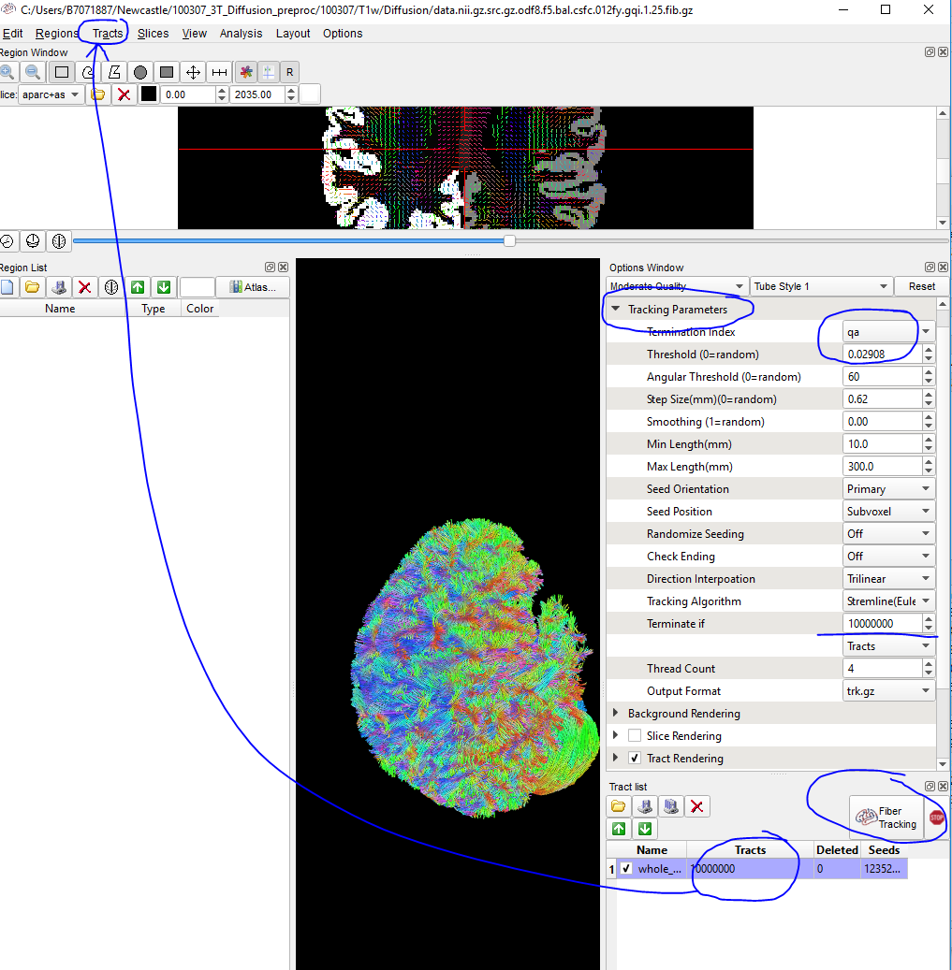

Fig.5 Fiber Tracking (parameter setting and save results)

***Step 3:***

Unzip ‘trk.gz’ file and download into Matlab to get high-resolution network.

The code can be divided into four parts:

1. […]=**conversion** (…); % **convert the tracking file into surface space and filter fibres whose endpoints terminating within the grey matter**

We use pial surface files (pial.surf.gii or pial) to get high-resolution **nodes** (be stored in ‘/100307_3T_Structural_preproc_extended/100307/T1w/100307/surf/lh(rh).pial.surf.gii or lh(rh).pial’, nodes are expressed by **triangles**). However, the three coordinate spaces of this surface file and of DK atlas (‘aparc+aseg.nii’, including grey matter segmentations), of ‘.trk’ file are different. So we must map tracking file into DK atlas space to filter fibres whose endpoints terminating within the grey matter and within the subcortical structures. And map these useful fibre endpoints into surface space to determine if there exist fibres between two **nodes**. The detailed progress is shown in Fig.6.

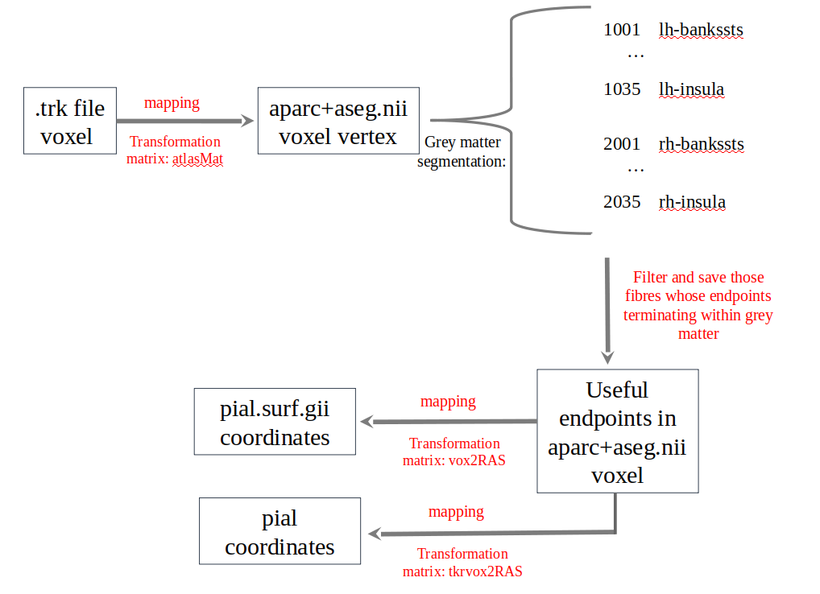Fig.6 conversion between three spaces

**Note**: Although our tracking files have been mapped in aparc+aseg.nii space when saving shown in *Step 2*(3. Fibre tracking), the directions of coordinates are different:

The coordinates (x, y, z) of ‘.trk’ file are defined from left to right (x), from posterior to anterior (y) and from superior to inferior (z, LPS system). The vertices inside the trk file are stored in units of millimeters (mm), so first transform these vertices into diffusion volume (or voxel index) by ‘trk_verts./voxel_size’, where trk_verts represents trk 3D vertices, and voxel_size(n,m,k) shows size of voxel, also stored in units of mm.

The orientation of 3D (a, b, c) in aparc+aseg.nii file are defined from left to right (a), from inferior to superior (b), from anterior to posterior and (c, LIA system). Different from trk file, aparc+aseg.nii is normally expressed by a 256*256*256 (or dim(1)*dim(2)*dim(3), where, dim is the dimension of aparc+aseg.nii) matrix. Values in matrix correspond to colour index of freesurfer color table (ref. <https://surfer.nmr.mgh.harvard.edu/fswiki/FsTutorial/AnatomicalROI/FreeSurferColorLUT>) . Different colour is denoted as special region. So aparc+aseg.nii is stored as volume (voxel index). In order to get scanner RAS coordinates in space from voxel index, transformation should be: vox2RAS*[volume(a,b,c), 1], where vox2RAS is a transformation matrix.

So the orientation transforming matrix between these two volume is $atlasMat=\left[1000;00−1dim\left(2\right);0−10dim\left(3\right);0001\right]$; only last two orientation should be changed.

Although both pial.surf.gii and pial files are surface format, their 3D coordinates are quite different. lh(rh).pial is using surface RAS (that is tksurfer) coordinate system. While lh(rh).pial.surf.gii is based on structure files, its surface coordinates is more or less same as the scanner RAS coordinates of aparc+aseg.nii. Thus transformation matrix is different: one is vox2RAS (from voxel to scanner RAS coordinates, which can be obtained by freesurfer command: mri_info aparc+aseg.nii --vox2ras), the other is tkrvox2RAS (from voxel to tk-surface RAS, which can be obtained by freesurfer command: mri_info aparc+aseg.nii –vox2ras-tkr).

aparc+aseg.nii file not only contains 68 cortical regions but includes 14 subcortical regions (lh/rh.thalamus, lh/rh.caudate, lh/rh.putamen, lh/rh.pallidum, lh/rh.amgdala, lh/rh.hippocampus, lh/rh.accumbens), brainstem and cerebellum. So here we add subcortical regions and brainStem, cerebellum into our high resolution matrix. So when filter the endpoints of trk file, keep the fibres who connect with subcortical structures.

1. […]=loadLabels (…); % according to the DK atlas coordinates to assign labels to pial surface nodes (i.e., triangles). Here, we assign labels by calculating the number of angles that belong to DK label (Fig.7)-- for cortical triangles:

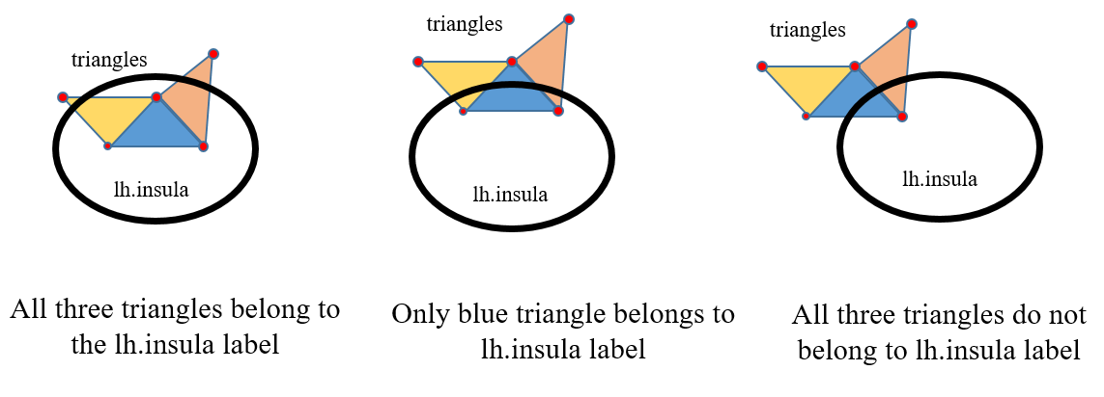

Fig.7 assign DK atlas label to each triangle

Only if more than one angle of a triangle are in DK atlas label, we consider this triangle belongs to this DK atlas region. Take ‘lh.insula’ label for example shown in Fig.7, the blue triangle in left panel has three angles in lh.insula region, we assign ‘lh.insula’ label to this triangle. By contrast, the blue triangle in the right panel do not belong to lh.insula region.

All DK atlas labels are extracted using freesurfer command:

mri_annotation2label --subject 100307 --hemi lh --surf pial.surf.gii --outdir ./labels

mri_annotation2label --subject 100307 --hemi rh --surf pial.surf.gii --outdir ./labels

where, --surf pial.surf.gii means all coordinates of labels are extract from pial.surf.gii. And ‘100307’ is the subfolder of '100307_3T_Structural_preproc_extended' and includes 'label', 'mri', 'surf', and 'touch' subfolders. If changes to –surf pial, coordinates will be based on lh(rh).pial file.

For subcortical regions: all subcortical regions are extract from apac+aseg.nii according to freesurfer color table and their coordinates should be mapped to pial.surf.nii or pial space. Here, we add 17 non-cortical structures: thalamus, caudate, putamen, pallidum, amgdala, hippocampus, accumbens, cerebellum, brain-stem. Thus, our matrix was arranged as: left cortical nodes, right cortical nodes, subcortical nodes. Within subcortical part, nodes are also ordered as left and right. The last alone node is brain-stem.

1. […]=makeEdgeList (…); % make edge list for remote connections derived from .trk endpoints and for local connections

Remote connections: nodes are connected when there exist at least one fibres. The centre of triangles will be the final location of cortical nodes. All cortical and subcortical nodes are gathered to recognize the final location of fibre endpoints. The first part (conversion.m function) has filtered all useful fibres whose endpoints terminating within grey matter or subcortical structures. Each endpoint of fibres corresponds to a pial node or subcortical node that has the closest distance with the endpoint.

Local connections: nodes are connected to their three local neighbours on each side. Local connections are made only for surface triangles.

The diagram of these two connections are shown in Fig.8.

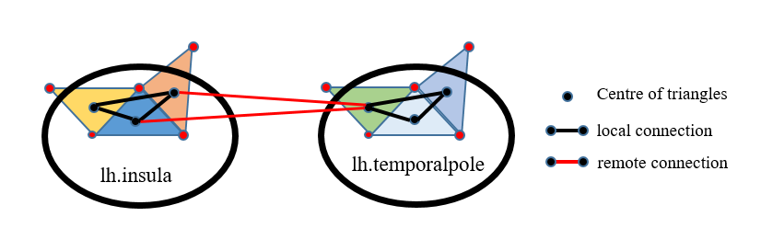

Fig.8 make edge list of local connections and remote connections

1. […]=getmatrices (…); % build a binary matrix combining local and remote connections.
2. […] = getMNIcoor(…); % using linear method to transform node coordinates into MNI305 or MNI152 space. Details: https://surfer.nmr.mgh.harvard.edu/fswiki/CoordinateSystems